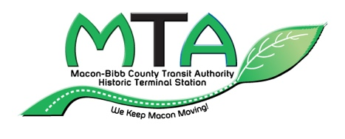
Public Comment Sign-in Sheet
Macon-Bibb County Transit Authority Board Meeting
Third Floor Conference Room — Terminal Station, 5:30 p.m.
Comments Limited to Up to Five (5) Minutes

Facilitator: Louis Frank Tompkins, Chairman

Meeting Date ____________________________

Name ____________________________________________________________

Address __________________________________________________________

__________________________________________________________

Email ____________________________________________________________

Phone Number ____________________________________________________

Topic (please briefly summarize your comment or concern)

_________________________________________________________________

_________________________________________________________________

_________________________________________________________________

_________________________________________________________________

Have you contacted the Macon-Bibb County Transit Authority about your topic previously? ______ Yes ______ No

If yes, result ______________________________________________________

______________________________________________________

